7. Echevennoz – Aosta 5th, 6th, 7th June
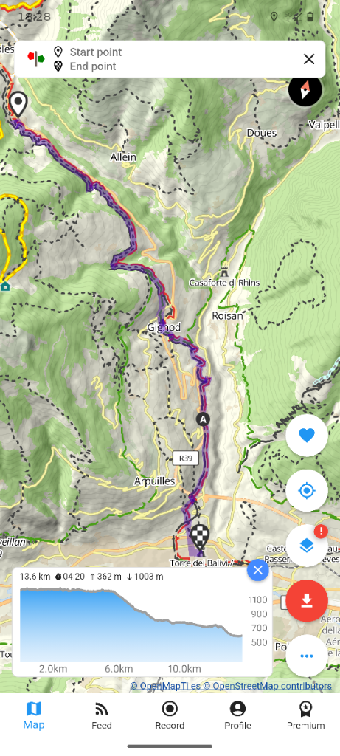

Aosta accommodation – 2 nights – rest day
Ristoro Foyer
Address: Rue Xavier de Maistre, 36, AO , 11100, Aosta , Italy

